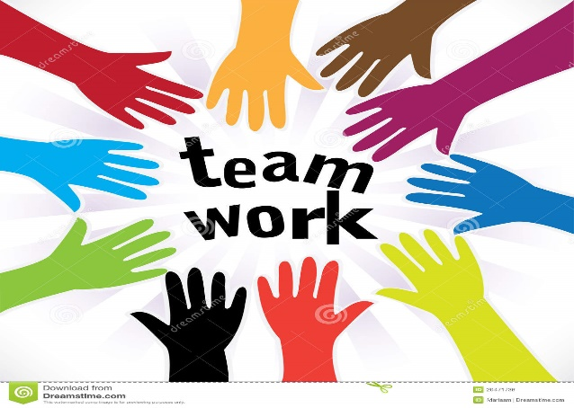
This Photo by Unknown Author is licensed under CC BY
2017-2018 President’s Report, Joyce Anderson
LWV Anchorage
STRENGTHENING OUR DEMOCRACY
and OUR COMMUNITY
First of all, I want to thank the board and our members for their support, energy, dedication and encouragement over these last five years. My time as President has been very rewarding and always a learning experience. I have seen our League grow and become an organization that is well known in the Anchorage area for community service with a nonpartisan agenda. I will continue to be an active member of League.

Our dedication to registering voters, increasing voter turnout and informing the public of election-related issues/concerns through education and advocacy was again exemplary. We need to give ourselves a big round of applause! A special thank you goes to League members who assisted with the many activities. I want to especially thank the League members who coordinated these many activities – taking the time to contact League members and then follow up with organizations/businesses. Without everyone’s dedication and commitment to League and our principles, we would not have accomplished our goals. Way to go!

I would like to highlight a few activities. Individual reports from our Voter Service Chair, Youth Vote Coordinator, Membership/Leadership/Development Chair, Membership/Outreach Chair, Website Chair and Ballot Review/Local Government Chair will provide more detail.

- Our Youth Vote program has expanded and is now a year-round project – with the addition of a bullying awareness campaign and “Power in Numbers” campaign focusing on educating and empowering youth voice and youth votes.
- In the voter service area, voter registration projects again included registering voters at Naturalization Ceremonies, Anchorage High Schools, UAA and other venues as well.
- We hosted Caroline Petti, from the Wash DC League, in October. She gave a presentation on Wash DC Statehood-Fixing the Hole in Democracy. The twenty-one attendees found the presentation enlightening and informative.
- Archiving of our records through UAA/APU Consortium Library took place in September. Twenty-four boxes of records were reviewed, sorted and consolidated. They were either archived, shredded or recycled. The records will be cataloged and then available for viewing by the public. What an excellent way for the League name and activities to be recognized!
- We again partnered with Alaska Common Ground who offered fiscal policy and transportation forums. The League offered voter registration services at several of the forums.

Our main focus for the last year has been the new Vote By Mail (VBM) system implemented for the Municipal Election held Tuesday, April 3, 2018. Pat Redmond and I have been members of the Anchorage Elections Stakeholder Group since 2015 when VBM was first explored as an option to polling place voting. The implementation process has been a long road.

The League’s role in spreading the word about VBM mushroomed over the last year through a partnership with the Muni Elections office. We took on the task of giving VBM Election Center tours, coordinating VBM presentations for the Muni by responding to on-line requests, giving VBM presentations, and delivering Special Needs ballots in the days prior to Election Day. We also assisted the residents at an Anchorage long-term care facility by providing information about the voting process and VBM. We delivered the voted ballots to the Election Center.

- Forty-One VBM presentations were given by fourteen League members from December 7, 2017 through April 2, 2018 to community councils, church groups, first Friday movie night at the Library, health fair event, food giveaway event, Women’s March, political party chapters, organizations, and businesses.
- Attendance at the VBM presentations varied with unofficial attendees totaling 1000. Additionally, the Women’s March had over 4,000 attendees, the Food Bank Christmas food give-away had hundreds of attendees and Bridge Builders 2018 Meet the World event also had hundreds of attendees.
- Voter registration services were offered at all the VBM presentations with hundreds either registering for the first time or updating their registration.
- Special Needs ballots were delivered to several hospitals.
- Youth Vote members scripted a PSA about voting and VBM. The PSA was geared toward our younger generation and proved to be entertaining and informative.
- Contracted with the Muni to again prepare and distribute the Ballot Review. VBM concerns were addressed in the Ballot Review and distribution was coordinated with the mailing of VBM ballots to 212,000 Municipality of Anchorage registered voters. The Ballot Review was mailed to every household in the Municipality of Anchorage. Many positive comments and thank you’s were received via email and phone.

As a member of the Alaska Division of Elections Election Policy Work Group, I represent the League. The Work Group is reviewing the current fiscal and policy challenges of conducting elections and the fact current voting equipment is becoming antiquated. The hope is to implement a new voting system for the State of Alaska for the 2020 elections. The State closely observed the Muni April 3, 2018 Vote by Mail election.

Keep up the good work!

