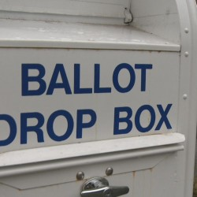
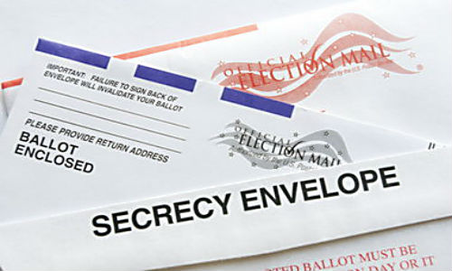

VOTE BY MAIL and Ballot Review
Joyce Anderson, Margaret McDonagh and Pat Redmond

The Anchorage League has been a member of the Municipality of Anchorage Elections Stakeholder Group since 2015 when Vote By Mail (VBM) was first explored as an option to polling place voting. Pat Redmond and Joyce Anderson have been on several committees – Education, Procedures, Procurement, and Implementation. Joyce Anderson also represented the Municipal Election Commission as a member of the commission. Many, many hours of meetings and dialogue contributed to the successful implementation of VBM. Kudos to Barbara Jones, Municipal Clerk, Amanda Moser, former Deputy Clerk Elections, and all elections staff and volunteers for a job well done!

The League’s role in spreading the word about VBM expanded over the last year through a partnership with the Municipal Clerk’s office and Barbara Jones, Municipal Clerk. Joyce Anderson and Margaret McDonagh took on the daunting task of coordinating VBM presentations. The Mayor’s office set up an on-line request form which was forwarded to the League for follow up. The request form was on the Mayor and Clerk’s office websites. Over the period December 7, 2017 through April 2, 2018, forty-one VBM presentations/booths were staffed. There were fourteen League members who helped with these activities. Voter registration services were provided at each of the venues. What an accomplishment!

A breakdown of the venues is listed below:
- Community Councils – 15
- Church Groups – 3
- Political Party Chapters – 3
- Organizations – 11 (Alaska Education Association, Anchorage Bartlett Club, Anchorage Woman’s Club, Mended Hearts, Prospector’s Club, Spenard Lion’s Club, Alaska Federation of Filipino Americans, AARP, Lion’s Club, Alaska Department of Environmental Conservation, Lion’s Club)
- Businesses – 3 (ConocoPhillips Civic Action Program, BP Community Action Program, Aleyeska Pipeline Service Company)
- Community Events – 6 (Food Bank of Alaska Neighborhood Gift 2017, Women’s March, Bridge Builders 2018 Meet the World, Anchorage AK Health Fair, Loussac Library 1st Friday Movie Night, Alaska Common Ground)

Attendance at the VBM presentations varied with unofficial attendees totaling 990. Additionally, the Women’s March had over 4,000 attendees who received VBM information at the beginning of the March and were able to register to vote at the conclusion – 49 registered. The Food Bank Holiday give-away had hundreds of attendees with 47 new registrations. Bridge Builders 2018 Meet the World event also had hundreds of attendees with some attendees completing new or updated registrations.

The project was successful because of members commitment to League and our principles – encourage informed and active participation in government. In other words, be informed about the new VBM system and be active by exercising your right to vote. Thank you to: Pat Redmond, Joan Diamond, Heather Flynn, Keri Clark, Shirley Pittz, Beth Haley, Barbara Norrell, Beth Nordlund, Schawna Thoma, Margaret McDonagh, Carol Dickason, Tina DeLapp and Joyce Anderson.

We had originally agreed to conduct once a month VBM tours at the Election Center. The training session was attended by six members. After conducting one tour, it was decided that Elections Staff would conduct the tours since they were already at the Center. Additional tours were scheduled as well.

The week prior to Election Day we were asked if members could deliver Special Needs Ballots to area hospitals and other health care facilities. In previous years, there had been about twenty such requests. Tina DeLapp, Heather Ireland, Keri Clark, Marie Murdock and Schawna Thoma volunteered to provide this service. At of the time of this writing the number of requests is unknown.

Cari Zawodny, Youth Vote Coordinator, worked with YV members to script a PSA about voting and the new VBM system. The PSA is geared toward our younger generation was posted on our social media sites; Facebook, Instagram and Twitter. It is exciting to have youth engaged in promoting youth voice and voting. Youth is the hope of our future.

The traditional League Ballot Review pamphlet was again prepared and delivered to all households in the Municipality of Anchorage. Pat Redmond was the main coordinator of this project. Carol Dickason spent many hours, days and weeks gathering information and putting it in a form that could be used by our design contractor, Meg Visgar of Print Works. Meg has put the document in printer ready form the last few years and is a joy to work with. Anchorage Board members and various municipal staff members were also major contributors. This year we had more than 200 telephones calls referencing the Ballot Review in positive comments even while seeking a clarification, more information or a suggestion for the next time we publish the Ballot Review. Many thank you’s were received via email also.

This year we printed 122,000 of the 8 page, 4 color 2018 Ballot Review. 115,441 copies were mailed to Anchorage households. The remainder were available for distribution to Accessible Vote Centers, the Senior Centers and the library. We also made the Ballot Review available to the various organizations that we spoke to regarding Vote By Mail. The printing charge was $26,746.71. The mailing fee was $19,105.70. This leaves a balance of $5,250.50 for coordination, design and editing. This is the amount that comes into the LWV Anchorage Treasury.

